Formal Lab Report Sample B
Hill Allen
11/26/2023
Chem 2081

Introduction
The purpose of this lab report is to analyze Nuclear Magnetic Resonance (NMR), Gas chromatography–mass spectrometry (GCMS), and Fourier Transform Infrared Spectroscopy (FTIR) results and correctly predict the structure of the unknown molecule these graphs have been created by. These methods are useful in differentiating molecules with similar structures and functional groups.

Body
Nuclear Magnetic Resonance (NMR)
NMR is used to determine connectivity of atoms in a molecule. NMR instruments use a technique called pulsed Fourier transform NMR. In this technique pulses of electromagnetic radiation excite hydrogen and carbon nuclei. The oscillation of carbon and hydrogen nuclei form a sine curve called the free induction decay (FID). This sine curve is then converted to a set of frequencies that can be analyzed to determine the structure of a molecule. Analyzing the splitting, chemical shift, and integration values of the frequencies can then help determine the molecule’s structure.
Gas chromatography–mass spectrometry (GCMS)
GCMS is used to analyze mixtures of compounds by providing components of the mixture. GCMS combines gas chromatography and mass spectrometry. GCMS is performed by ionizing sample molecules by electron impact and analyzing the mass of the resulting ions in a mass analyzer. The stream of ions is then passed through parallel rods with AC and DC currents. These currents affect ion trajectories and caused them to oscillate. Only ions with stable oscillation collide with the mass detector. This results in a mass spectrum for a compound. This mass spectrum can then be used to determine molecular weight of a molecule and Structural elements of a molecule.
Fourier Transform Infrared Spectroscopy (FTIR)
FTIR is used to determine the presence of functional groups in a molecule. FTIR graphs are created by passing mid-infrared energy through an organic compound. This causes bending and stretching vibrations in a molecule. The bending and stretching of bonds creates a frequency that can be used to form a unique IR spectra for a given molecule. Between 4000 cm⁻¹ and 600 cm⁻¹ is the region of interest because this is where absorptions from organic compounds appear. The positions of these absorption bands provide information about what functional groups are in a molecule.

Data
Sample B data sheets attached below.
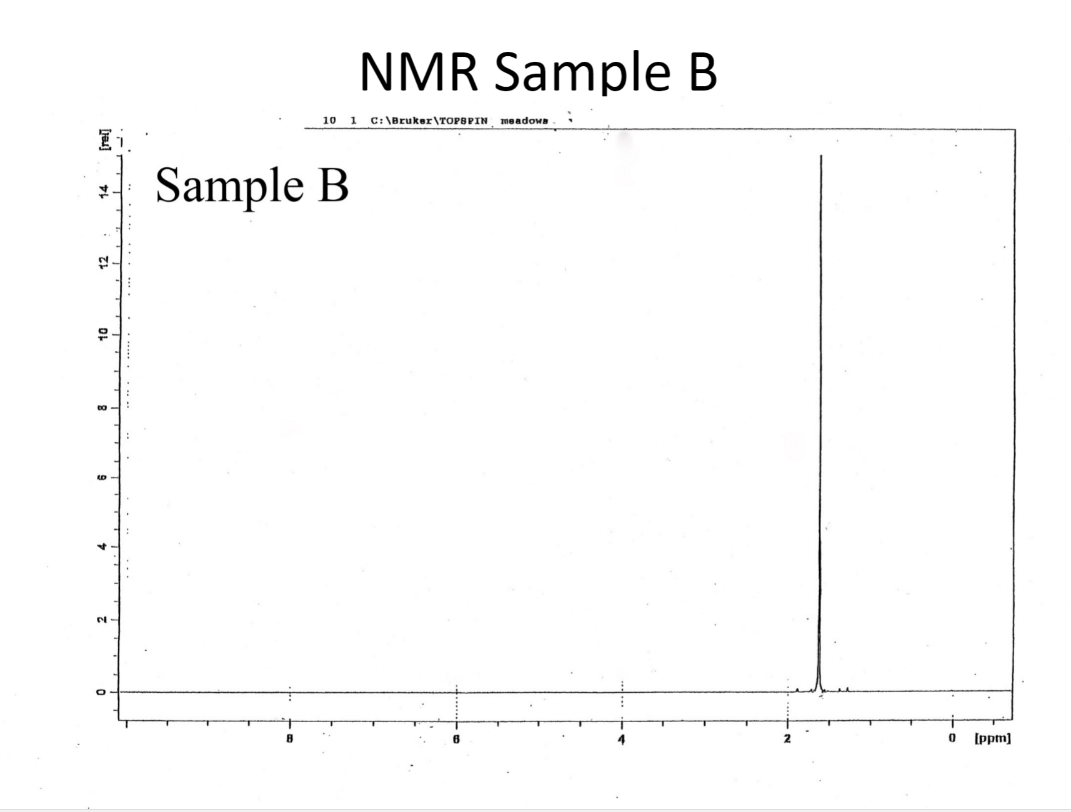
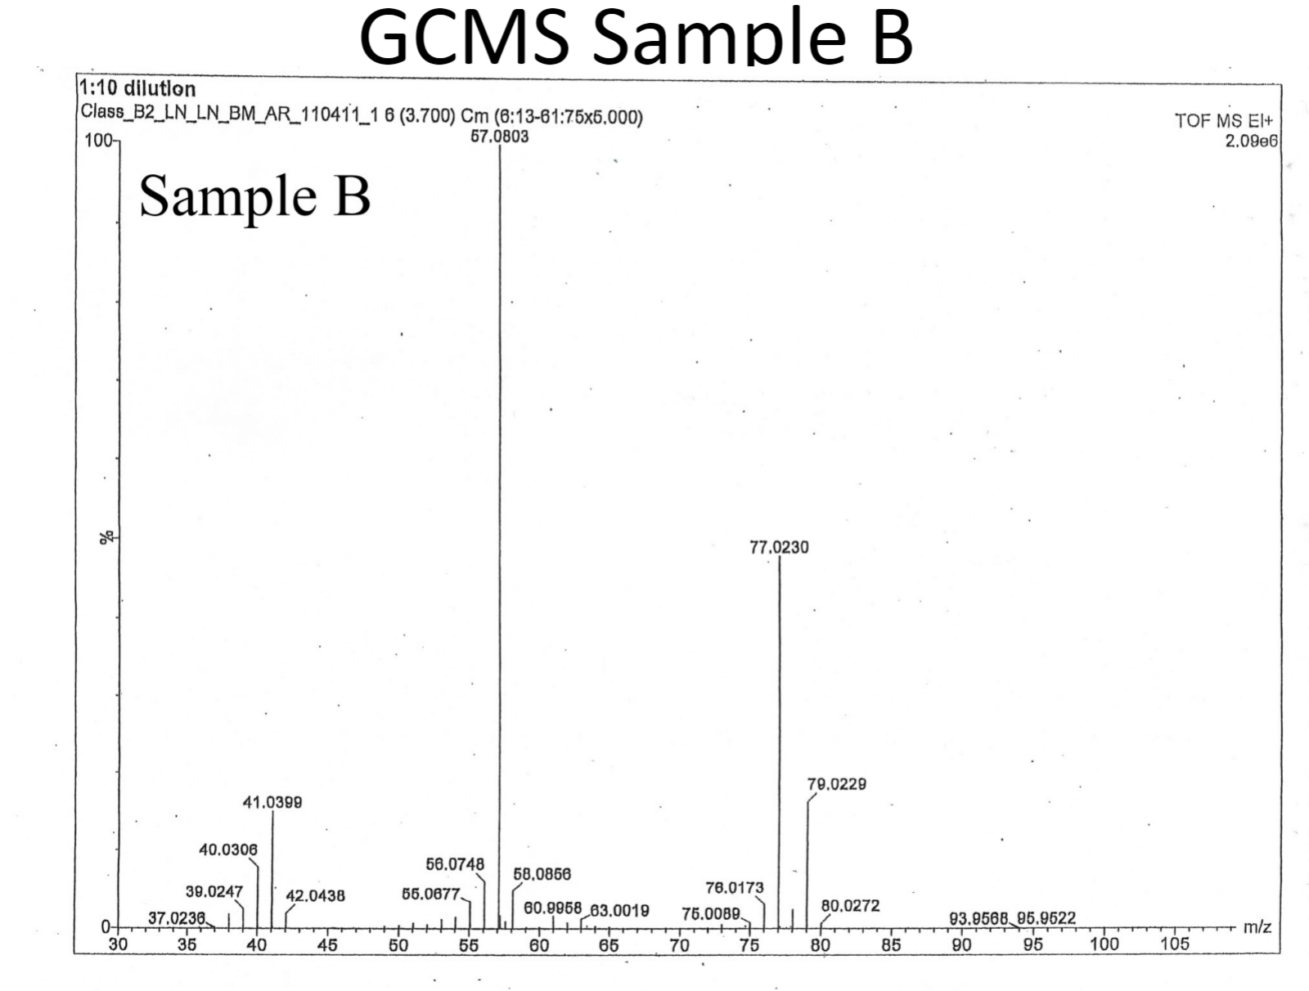
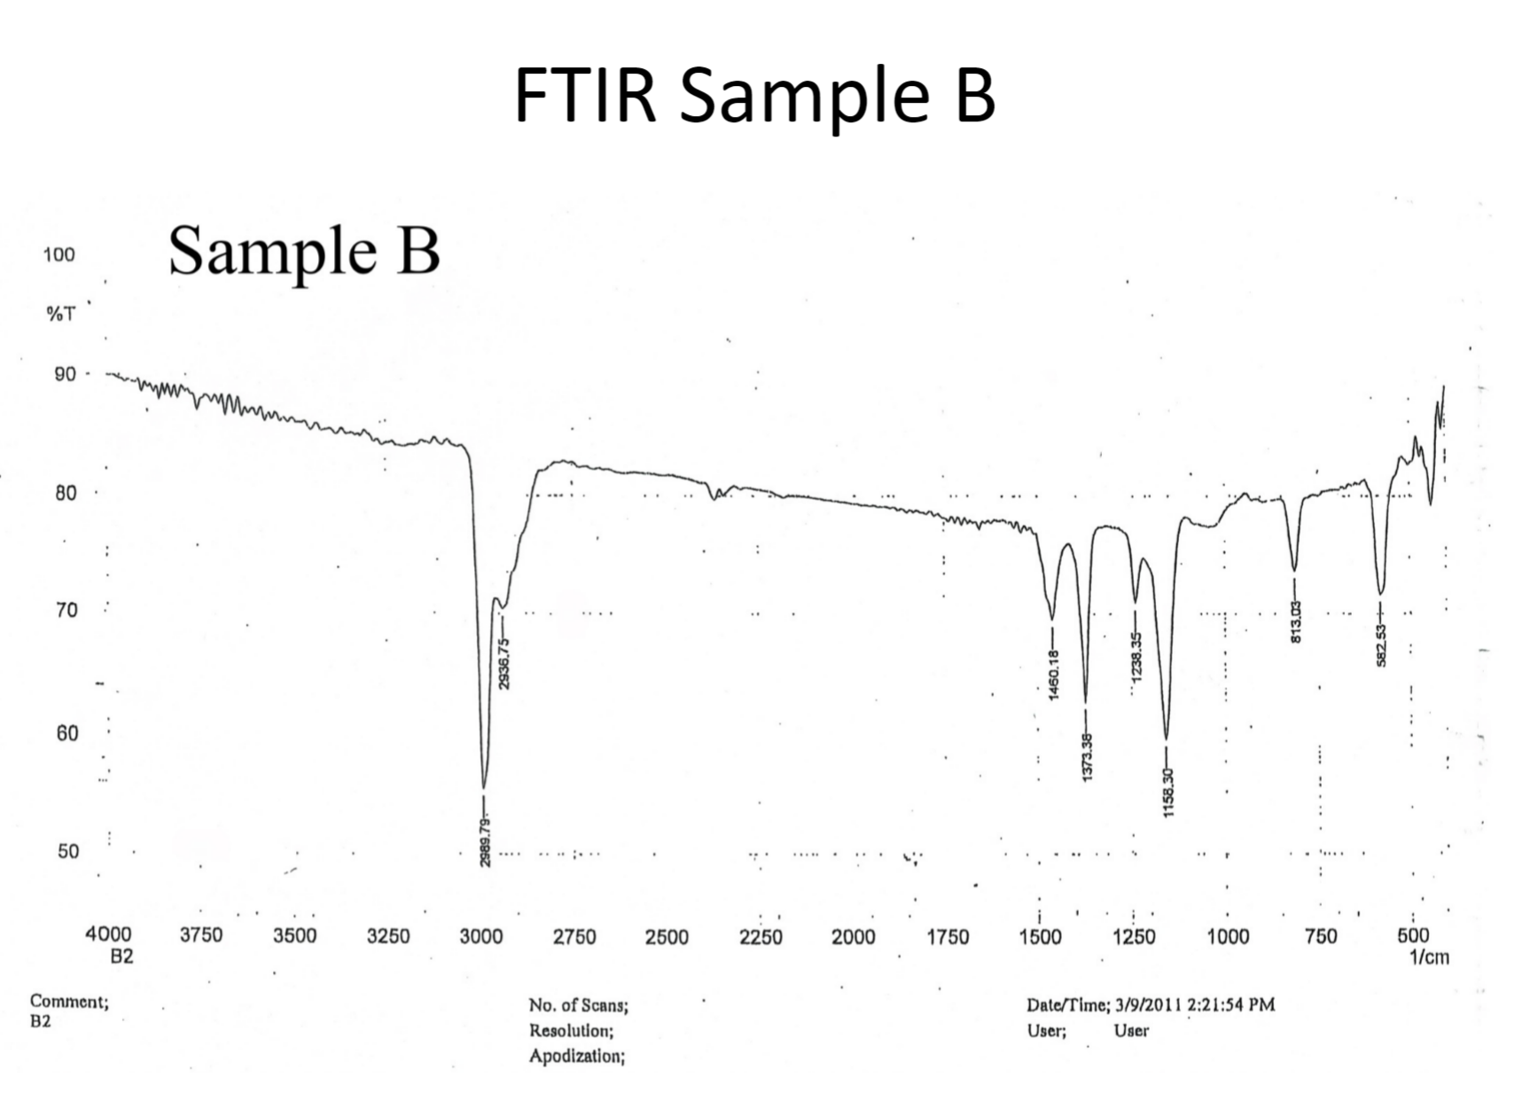

Discussion
Each of these data sheets gives a piece of key information about the structure of the molecule. Starting with the NMR data sheet. The NMR data sheet shows only one signal being split. This shows that there is only one type of hydrogen in this molecule and there are multiple of this one type as shown by the splitting. The splitting in the NMR graph also shows that these hydrogens have no neighboring hydrogens. This peak also displays some chemical shift which would be consistent with the presence of a chlorine atom. Then using the GCMS data the molecule can be further analyzed. The base peak of this molecule is at m/z 57.08. This shows that the most stable cation of the molecule has a molecular weight of 57.08 amu. The M+ peak in the GCMS can be used to identify the molecular weight of the compound. In the GCMS reading for sample B the M+ peak was at 93.96. The M+ peak also demonstrates the presence of a chlorine atom in the molecule because of the 3:1 ratio between the heights of M+ peak and the M+2 peak. In the GCMS reading the base peak was also consistent with the molecular weight of a C₄ H₉ carbocation at 57.08 amu. Finally, the FTIR graph of sample B. The FTIR graph shows a peak at 2989.79 and 2936.75 which are consistent with Carbon to hydrogen bonds. There is no activity in the graph signaling double or triple bonds. There is activity between 1460.18 and 1158.30 which indicates methyl groups. There is also strong activity at 850-550 indicating the presence of a C-Cl bond. Using the information gathered the molecule is predicted to be tert-butyl chloride or 2-chloro-2-methylpropane.

Results
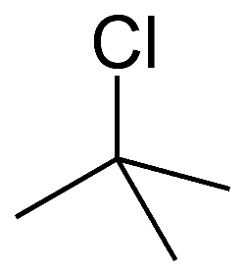
The Structure of Unknown B is tert-butyl chloride (2-chloro-2-methylpropane). Its structure is shown below.
References
Keller L, Joseph K, and Miguel S. 2023 Fall. CHEM 2081 Organic Chemistry II Lab Manual [lab manual]. Auburn (Al): Auburn University.

